California Scholarship Federation
Community Service Hours Form
The California Scholarship Federation emphasizes high standards of service, scholarship, and citizenship for California high school students. CSF encourages service to the school and community while fostering pride in scholastic achievement.
Name:__________________________ Year_________ Semester: 1st 2nd
Name of Organization:_____________________ Number of Hours:________
Supervisors Signature:_____________________ Date: _______________
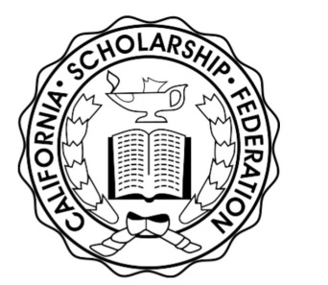
_ _ _ _ _ _ _ _ _ _ _ _ _ _ _ _ _ _ _ _ _ _ _ _ _ _ _ _ _ _ _ _ _ _ _ _ _ _ _ _ _ _ _ _ _ _ _ _ _ _ _ _
California Scholarship Federation
Community Service Hours Form
The California Scholarship Federation emphasizes high standards of service, scholarship, and citizenship for California high school students. CSF encourages service to the school and community while fostering pride in scholastic achievement.
Name:__________________________ Year_________ Semester: 1st 2nd
Name of Organization:_____________________ Number of Hours:________
Supervisors Signature:_____________________ Date: _______________

